Template and formatting guidelines for THE PAPERS OF THE TecniAcústica 2026 CONGRESS
First1 Surname1^{1,*}, First2 Surname2¹, First3 Surname3², First4 Surname4³
¹ Acoustics Group, University A, Spain
² Applied Acoustics and Vibration Laboratory, University B, Spain
³ Acoustic Engineering Laboratory, Faculty of Engineering, University C, Portugal
* Corresponding author: email@email.uk

Abstract. This document is the official template for papers of the 14th Iberian Congress on Acoustics and 57th Spanish Congress on Acoustics, TecniAcústica 2026, to be held in Granada from October 21st to 23rd 2026. The template is available in both LaTeX and Word, with visually equivalent output, in order to ensure uniformity of the Proceedings regardless of the tool used. The abstract should clearly and concisely summarise the objectives, methodology, main results and conclusions of the work, without exceeding 250 words and without including equations, figures, numbered references or footnotes. The abstract should not continue to page 2. Papers may be written in English, Spanish or Portuguese. Papers written in English require only an abstract and keywords in English. Papers written in Spanish or Portuguese additionally require an abstract in Spanish or Portuguese (see their corresponding templates). The full length of the paper must be between four and eight pages, including figures, tables and references.
Keywords: acoustics, indexing, template, TecniAcústica 2026

Introduction
These instructions describe the format required for papers submitted to the TecniAcústica 2026 Congress. Their purpose is to ensure uniformity of the Proceedings and to facilitate their DOI assignment. Authors are encouraged to write their paper directly on this template, replacing the sample text with their own content and respecting the predefined styles. Every element of the document (title, authors, affiliations, abstract, headings, body text, captions and references) has an associated Word paragraph style; always use these styles instead of applying manual formatting.
Papers may be written in English, Spanish or Portuguese. A paper written in English requires only an abstract and keywords in English. A paper written in Spanish or Portuguese additionally requires an abstract in Spanish or Portuguese (see their corresponding templates), with keywords in both languages. The exclusive use of International System (SI) units is recommended; where non-SI units are used, their SI equivalent must be given in parentheses.

Structure of the first page
The first page acts as a cover page and its layout is fixed. The congress banner and the logos of the organising societies appear only on this page: the banner in the header and the logos in the footer, above the copyright note. The remaining pages carry no banner or logos, only a running header with the author surnames (even pages) or the congress name and dates (odd pages).
The order of the elements on the cover page is: title, authors, affiliations, corresponding author, abstract and keywords. The text of the body of the paper (including this section) always begins on the following page: in this Word template, the separation is achieved by a manual page break placed after the keywords. If the abstract is of maximum length and, owing to the number of authors or affiliations, runs over onto the second page, remove that break and start the text of the body immediately below. This separation is deliberate: the title, authors and affiliations always occupy the same position, regardless of the length of the abstract, which keeps all papers consistent and preserves equivalence with the LaTeX template.

Manuscript format

Page size and margins
All papers must be prepared in A4 size (210 mm × 297 mm), with margins of 25 mm left and right and 35 mm top and bottom. The text is set in a single justified column. These values are fixed in the template and must not be modified.

Typography
The body font is Times New Roman at 11 pt with single line spacing. No first-line indentation is used; paragraphs are separated by a small vertical space. The abstract is set at 10 pt to distinguish it from the body text. These formats are captured in the Word styles “Normal” (body) and “Abstract block”. Do not modify the predefined fonts, sizes or spacing.

Headers, footers and page numbers
Even pages carry the author surnames in short form in the header, that is, the surnames of up to three authors separated by commas, or the surname of the first author followed by “, et al.” if more than three authors; odd pages present the congress name and dates. The headers are already configured in the template: edit only the surnames in the even-page header (double-click on it to edit). Do not number the pages: page numbers and the identifier will be added by the organisers when assembling the proceedings. Do not add any additional content to headers or footers.

Section headings
The template allows up to three heading levels, numbered automatically through the Word styles “Heading 1”, “Heading 2” and “Heading 3”. Level 1 is set in 14 pt bold; levels 2 and 3 in 11 pt bold (level 3 also in italics, to distinguish it). The Acknowledgements and References sections are not numbered: apply the “Unnumbered heading” style to them. The use of the third level is discouraged unless strictly necessary.

Figures, tables and equations

Figures
Figures must be placed close to where they are first mentioned and centred horizontally. Each figure must present a consecutively numbered caption, placed below the figure with the “Figure/table caption” style, as shown in Figure 1. The number is generated by an automatic Word field: the simplest approach is to copy an existing caption and edit its text; after adding, deleting or reordering figures, update the numbering by selecting the whole document and pressing F9. High-quality images (PNG, TIFF or EMF) are recommended whenever possible and, for raster images, a minimum resolution of 300 dpi. Any figure, image or copyrighted material requires permission from the rights holder before publication.
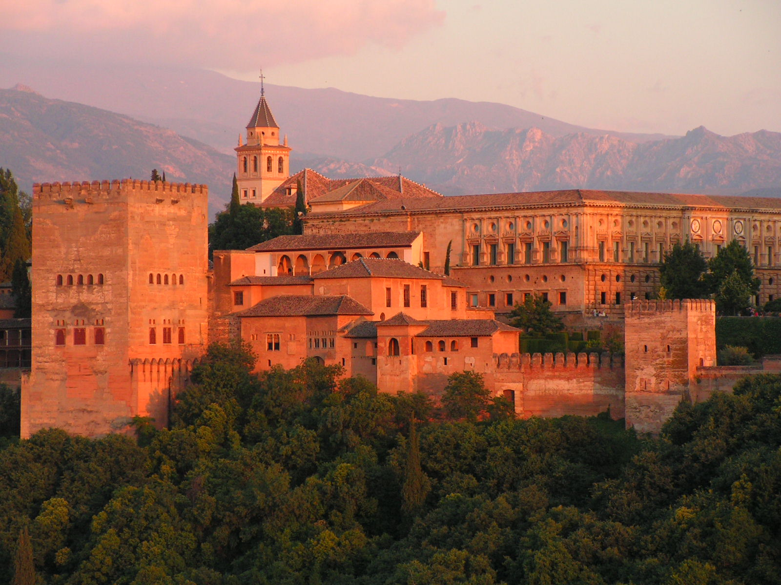
Figure 1 – Example of a figure with its centred caption and consecutive numbering.

Tables
Tables must be centred horizontally and present their caption above the table, using the same style and automatic numbering as figure captions, as shown in Table 1. Horizontal rules only are recommended and vertical rules should be avoided. Where appropriate, indicate units in square brackets in the table header.
Table 1 – Density of some solid and fluid materials.
Material | Density [kg/m³]
Air | 1.21
Water | 1000
Steel | 7850

Equations
Equations must be inserted with the Word equation editor (Insert → Equation), centred and separated from the text, and numbered consecutively with Arabic numerals in parentheses, aligned to the right margin using the predefined tab stop, as in Equation (1). Use conventional symbols and SI units.
$∇^{2}p+k^{2}p=0,$ (1)
where p is the acoustic pressure and k the wavenumber.

Citations and references
References are cited in the text with numbers in square brackets [1] and listed at the end of the paper with the “References” style, numbered in order of appearance, following the IEEE numeric style [2, 3]. Every reference in the list must be cited in the text and vice versa.

Submission and publication
Papers must be submitted in PDF format through the congress website. Generate the PDF from Word (File → Save As → PDF, or File → Export), checking that fonts are embedded. The file must not exceed the maximum size stated in the submission guidelines. Before submitting, carefully check the final PDF to verify that the conversion was performed correctly and that no figure, table or equation falls out of place. For a paper to be included in the programme and the Proceedings, at least one of the authors must complete registration and pay the corresponding fee by the deadline.

Conclusions
This template gathers all the elements needed to prepare a paper in accordance with the TecniAcústica 2026 Congress guidelines. By respecting the predefined styles and not altering the page setup, the result will be uniform and equivalent in both Word and LaTeX.

Acknowledgements
Acknowledgements of funding, institutions or colleagues are included in this section, placed after the conclusions and before the references. It is not numbered.

References
- C. L. Morfey, Dictionary of Acoustics. San Diego, USA: Academic Press, 2001.
- L. E. Kinsler, A. R. Frey, A. B. Coppens, and J. V. Sanders, Fundamentals of Acoustics, 4th ed. New York, USA: Wiley, 2000.
- ISO 3382-1:2009, Acoustics — Measurement of room acoustic parameters — Part 1: Performance spaces. International Organization for Standardization, 2009.

